- The uptick in UK CPI inflation in July was in line with our expectations. The increase was primarily due to base effects in the energy category, following a smaller drop in the price cap than was seen last year. As a result, our inflation forecast is little changed, and we expect CPI inflation to average 2.5% this year and next.
- Large base effects will cause some month-to-month volatility in headline inflation rates over the next few months. We expect CPI inflation to gradually drift upwards in towards the end of this year as the drag from the energy category continues to fade.
In line with our forecast, CPI inflation edged up to 2.2% in July from 2% in June. July's higher headline rate reflected a smaller drag from the energy category – though Ofgem's energy price cap was cut by nearly-7% in July, it had fallen by more than twice as much in that month last year. But this was partly offset by softer services inflation, some of which was due to the unwinding of June's unusual spike in hotel prices.
Elsewhere, RPI and RPIX inflation rose to 3.6% and 2.7% respectively in July, from 2.9% and 1.9% in June. The larger increases for these measures reflected a sharp drop in the drag caused by 'other differences between CPI and RPI, including weights'.
Given today's data came in broadly as expected, and there has been little movement in the underlying drivers, our inflation forecast is little changed compared with last month. We expect CPI inflation to average 2.5% in 2024 and 2025.
Large base effects, reflecting unusual seasonal movements in services prices last summer, are likely to cause some volatility in inflation rates over the next few months. Thereafter, the shrinking drag from the energy category will push headline inflation higher around the turn of the year, more than offsetting a cooling in core inflation as firms increasingly reflect their lower energy costs in their prices.
Chart 1: Inflation is forecast to average 2.5% in 2024 and 2025
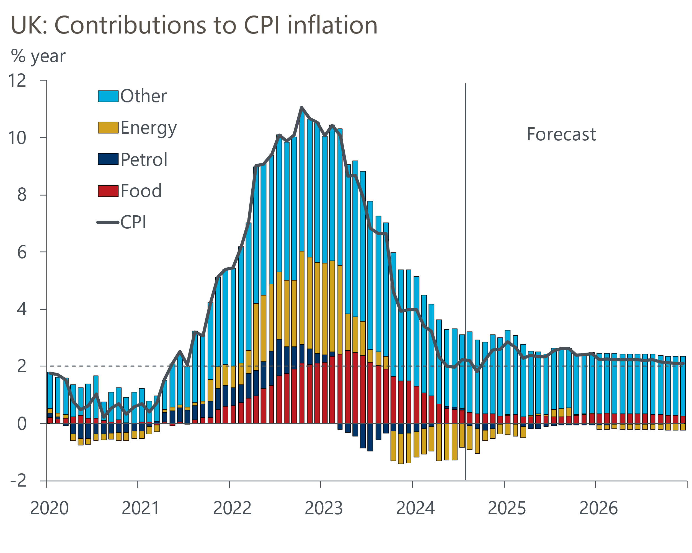
Source: Oxford Economics, Haver Analytics

